**Curriculum Vitae**

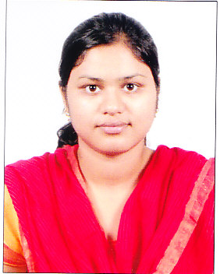

Name : Nikitasa Nanda

Phone No. **:** +919556806617

Email **:** [nikitasha.nanda13@gmail.com](mailto:nikitasha.nanda13@gmail.com)

**Objective:**

* Intend to build a career in hi-tech environment which can offer me a platform for my professional and personal growth.
* To emerge as an IT professional and prove myself as an important part of the organization by the achievement of the given targets and to work in challenging projects that will utilize my educational background and expand my knowledge.

**Personal Skills:**

* Achievement oriented with excellent people management skills.
* Strongly believes in sincerity, hard work and is eager to learn.
* Excellent team building and leadership skills.

**Academic Details:**

* Completed MCA (Masters in Computer Application**)** in2015 from Trident Academy of Technology with CGPA 8.3, Bhubaneswar, under B.P.U.T., Odisha
* Completed BCA(Bachelor in Computer Application) in 2012 with 71% from Trident Academy of Creative Technology, Bhubaneswar under Utkal University, Odisha

.

* Completed Intermediatein 2009 with 52% from Saraswati +2 Science College, Bhawanipatna, under C.H.S.E., Odisha
* Completed Matriculationin 2007 with 77% from B.N.KBidyapithaArebeda, Kalahandi, under B.S.E., Odisha

**Professional Skills:**

* Having programming skills in
* **C,C++,Java,Html,CSS,JavaScript,Servlet,JSP,JDBC**
* Database :
* **Oracle 10G**

**Project Profile:**

* **Completed Project On “Job Portal”**

**Framework in Advance Java with Struts 1.X**

**Front End-Adv Java**

**Back End-Oracle 10G**

**Additional Qualification:**

* **Computer Hardware And Networking**

Under Central Tool Room and Training Center (CTTC)

**Personal Details:**

**Name :** Nikitasa Nanda

**Father’s Name** Santosh Kumar Nanda

**Date of birth :** 30th July 1992

**Gender :** female

**Marital status :** Single

**Nationality :** Indian

**Languages known :** English, Hindi, Oriya

**Hobbies :** Learning about new Technologies,

Travelling, Reading Books, Singing.

**Phone No. :** +919556806617

**Email :** [nikitasha.nanda13@gmail.com](mailto:nikitasha.nanda13@gmail.com)

|  |  |
| --- | --- |
| **Declaration:** |  |

I hereby declare that, all the statements made in the above are correct and true to the best of my knowledge and belief.

Place: Bangalore

Date: Nikitasa Nanda